BOOK STORE PROJECT SQL

CREATE DATABASE bookshopDB

USE bookshopDB

SELECT*FROM books

SELECT*FROM Customers

SELECT*FROM Orders

Basic Queries
1) Retrieve all books in the "Fiction" genre
SELECT
COUNT(*) AS fiction_books
FROM books
WHERE genre ='fiction'

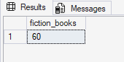
2) Find books published after the year 1950
SELECT book_id,title,Author,Genre,Published_year,
ROUND(Price,2) AS Price,
stock
FROM books
WHERE published_year > 1950

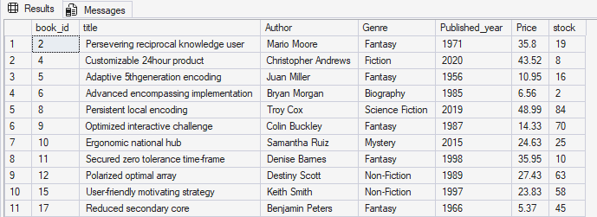
3) List all customers from the Canada
SELECT*FROM customers
WHERE country='canada'

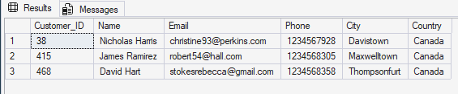

4) Show orders placed in November 2023
SELECT Order_id,customer_id,Book_id,Order_date,quantity,
ROUND(total_amount,2) AS total_amount
FROM orders
WHERE order_date BETWEEN '2023-11-1' AND '2023-11-30'

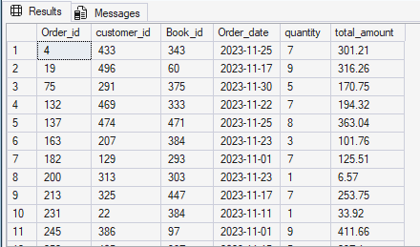
5) Retrieve the total stock of books available
SELECT SUM(Stock) AS Total_stock
FROM books

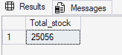

6) Find the details of the most expensive book
SELECT Book_id,title,Author,Genre,Published_year,
ROUND(price,2) AS Price,
Stock
FROM books
WHERE Price=(SELECT MAX(Price) from Books)

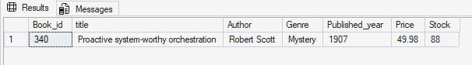

7) Show all customers who ordered more than 1 quantity of a book
SELECT order_id,customer_id,book_id,Order_date,quantity,
ROUND(total_amount,2) AS total_amount
FROM orders
WHERE quantity> 1

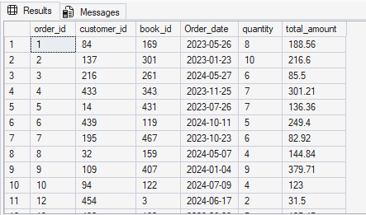

8) Retrieve all orders where the total amount exceeds $20
SELECT order_id,Customer_id,Book_id,Order_date,Quantity,
ROUND(total_amount,2) AS total_amount
FROM orders
WHERE total_amount> 20

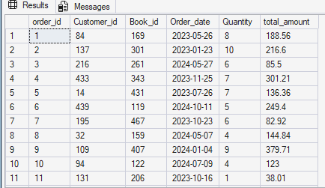

9) List all genres available in the Books table
SELECT DISTINCT genre FROM books

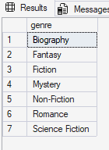
10) Find the book with the lowest stock

SELECT TOP 1 Book_id,title,Author,Genre,Published_year,
ROUND(price,2) AS Price,
stock
FROM books
WHERE Stock=( SELECT MIN(stock) FROM books)

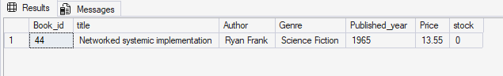

11) Calculate the total revenue generated from all orders
SELECT SUM(Total_Amount) AS total_revenue
FROM orders

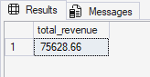

Advance Queries
1) Retrieve the total number of books sold for each genre
SELECT b.genre,
SUM(o.quantity) AS Total_quantity
FROM books b
JOIN orders o
ON b.book_id=o.book_id
GROUP BY b.genre
ORDER BY Total_quantity

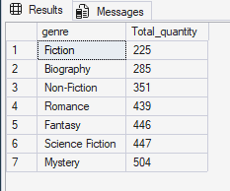
2) Find the average price of books in the "Fantasy" genre
SELECT ROUND(AVG(Price),2) AS Avg_price
FROM books
WHERE genre='fantasy'

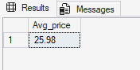

3) List customers who have placed at least 2 orders
SELECT o.customer_id,
c.name,
COUNT(o.order_id) AS order_count
FROM orders o
JOIN customers c
ON c.customer_id=o.customer_id
GROUP BY o.customer_id,c.name
HAVING COUNT(order_id) >=2

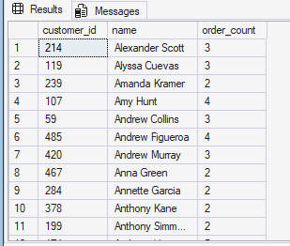

4) Find the most frequently ordered book
SELECT TOP 1
o.book_id,
b.title,
COUNT(o.order_id) AS Order_count
FROM Orders o
JOIN books b
ON o.book_id=b.book_id
GROUP BY o.book_id,b.title
ORDER BY order_count DESC

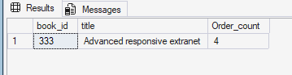

5) Show the top 3 most expensive books of 'Fantasy' Genre
SELECT TOP 3 Book_id,title,Author,Genre,Published_year,
ROUND(price,2) AS Price,
Stock
FROM BOOKS
WHERE GENRE='FANTASY'
ORDER BY ROUND(price,2) DESC

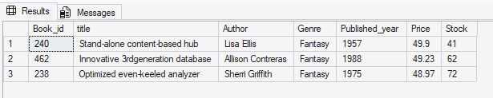

6) Retrieve the total quantity of books sold by each author
SELECT b.author,
SUM(o.quantity) as total_quantity
FROM orders o
JOIN books b
on b.book_id=o.Book_id
GROUP BY Author
ORDER BY Total_quantity DESC

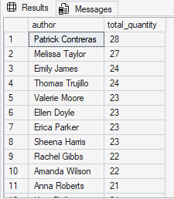

7) List the cities where customers who spent over $30 are located
SELECT DISTINCT C.city,
ROUND(o.total_amount,2) AS total_spent
FROM customers c
JOIN orders o
ON c.customer_id=o.customer_id
WHERE total_amount>30
ORDER BY ROUND(total_amount,2) DESC

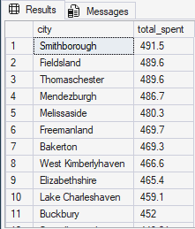

8) Find the customer who spent the most on orders
SELECT TOP 1
c.customer_id,
c.name,
SUM(ROUND(o.total_amount,2)) AS total_Spent
FROM customers c
JOIN orders o
ON c.customer_id=o.customer_id
GROUP BY c.customer_id,c.name
ORDER BY total_spent DESC

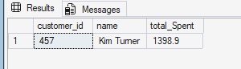

9) Calculate the stock remaining after fulfilling all orders
SELECT b.book_id,b.title, b.stock, COALESCE(SUM(o.quantity),0) AS order_quantity,
b.stock, COALESCE(SUM(o.quantity),0) AS remaining_quantity
FROM books b
LEFT JOIN orders o
ON b.book_id=o.book_id
GROUP BY b.book_id,b.title,b.stock
ORDER BY b.book_id

